### STORE MANAGER: KEEP TRACK OF INVENTARY

**Project Documentation**

**Project Title: Store Manager: Keep Track of Inventory**

**Team ID**

**Team Leader: Nasreen banu .S & nazvivo2006@gmail.com**

**Team Members: Nasreen fathima. A & nasreen12062006@gmail.com**

**Team Members: Swetha.Y & swethay2007@gmail.com**

**Team Members: Gayathri .G &** **gayathri133gayuuu@gmail.com**

# INTRODUCTION

**INTRODUCTION**

Inventory management is a crucial part of any retail or product-based business, regardless of its size. While large companies use complex ERP systems to manage their stock and sales, many small shops and businesses still rely on outdated methods such as handwritten notes, Excel sheets, or basic billing tools. These manual approaches are time-consuming, error-prone, and lack real-time updates or meaningful data tracking. Problems such as inaccurate stock levels, missed restocking opportunities, and loss of sales history are common in such systems. To address these challenges, there is a need for a simple, effective, and easy-to-use digital tool that helps small business owners manage their inventory and track sales without the overhead of backend servers or expensive software. The project titled **"Store Manager: Keep Track of Inventory"** is designed as a lightweight, frontend-based inventory management application that fulfills this exact need. Built using **ReactJS** and relying on **Chrome Local Storage** for data handling, the system provides an efficient and user-friendly platform to manage products, monitor stock, and record sales with minimal technical setup.

This project is divided into five main tabs: **Home, Cart, Sales, Inventory**, and **Add Product**. The Home tab displays all available products with options to "Add to Cart" or "Remove from Cart" and includes a search bar for quick filtering. The Cart tab collects selected products and allows the user to either **Checkout**, which updates the stock and records the sale, or **Clear** the cart without processing. Completed transactions are recorded and displayed in the **Sales** tab, showing key details like product names, quantities, total sale value, and the date and time of the transaction. The **Inventory** tab provides features to update stock levels and set alert thresholds for low stock items. Products that fall below the set alert value are highlighted in red, and users can filter the view to show only depleted items. The **Add Product** tab allows for adding new products by entering details like name, image URL, price, stock quantity, and tags. All of this data is stored in the browser’s **Local Storage**, which means the application works without any backend database or server setup and can retain data across browser sessions.

The use of ReactJS makes the interface dynamic, modular, and responsive, allowing users to interact with the system in real time. Each component of the application is designed with clarity and simplicity, ensuring even users with little technical knowledge can operate it effectively. Moreover, the application can function offline since all operations are handled on the client side, making it ideal for small businesses that may not always have internet access. While the current version uses Local Storage for simplicity, the structure of the project allows for easy future upgrades to integrate with backend technologies like **MongoDB** or **Firebase** if needed. The goal of this project is not only to demonstrate technical skills in frontend development using ReactJS but also to provide a **practical, working solution** that addresses a real-world problem. By streamlining sales tracking and inventory control into a single, browser-based tool, the system enhances efficiency, reduces manual errors, and gives small business owners better visibility into their operations. This project showcases how modern frontend technologies can be used to build functional applications that make a tangible difference in day-to-day business tasks.

# SOURCE CODE

**Cart.jsx :**

**import CartItem from "./CartItem";**

**import { useCart } from "../../context/CartContext";**

**import { useCartDispatch } from "../../context/CartContext";**

**import { useInventoryDispatch } from "../../context/InventoryContext";**

**import { useSalesDispatch } from "../../context/SalesContext";**

**export default function Cart() {**

**const inventoryDispatch = useInventoryDispatch();**

**const cartItemsFromContext = useCart();**

**const cartDispatch = useCartDispatch();**

**const saleDispatch = useSalesDispatch();**

**let count = 0;**

**let cartValue = 0;**

**if (cartItemsFromContext.length > 0) {**

**cartItemsFromContext.forEach((item) => {**

**cartValue += item.price * item.quantity;**

**count += item.quantity;**

**});**

**}**

**return (**

**<div className="min-h-screen flex flex-col items-center bg-sky-200 p-6 font-sans">**

**{/* Heading with emoji and uppercase */}**

**<h1 className="text-3xl font-extrabold uppercase text-black mb-4 flex items-center gap-2">**

**🛒 Your Cart**

**</h1>**

**{count === 0 ? (**

**<p className="text-lg text-gray-700">Your cart is empty.</p>**

**) : (**

**<div className="w-full max-w-3xl">**

**<p className="mb-4 text-lg">**

**No. of products in cart: <b>{count}</b> | Total Cart Value:{" "}**

**<b>{cartValue.toFixed(2)}</b>**

**</p>**

**<div className="mb-4 flex gap-2 flex-wrap">**

**<button**

**onClick={() => {**

**cartItemsFromContext.forEach((cartItem) => {**

**inventoryDispatch({**

**type: "STOCK_SOLD",**

**productName: cartItem.productName,**

**stock: cartItem.quantity,**

**});**

**});**

**saleDispatch({**

**type: "NEW_SALE",**

**saleValue: cartValue,**

**products: cartItemsFromContext,**

**});**

**cartDispatch({**

**type: "EMPTY_CART",**

**});**

**alert(**

**"Checkout successful! Inventory has been updated."**

**);**

**}}**

**className="bg-green-500 hover:bg-green-600 text-white font-bold rounded p-2 transition"**

**>**

**Checkout Cart**

**</button>**

**<button**

**onClick={() => {**

**cartDispatch({**

**type: "EMPTY_CART",**

**});**

**}}**

**className="bg-red-500 hover:bg-red-600 text-white font-bold rounded p-2 transition"**

**>**

**Clear Cart**

**</button>**

**</div>**

**<div className="flex flex-wrap justify-center gap-4">**

**{cartItemsFromContext.map((product) => (**

**<CartItem key={product.productName} product={product} />**

**))}**

**</div>**

**</div>**

**)}**

**</div>**

**);**

**}**

**Product.jxs :**

**import { useState } from "react";**

**import { useInventoryDispatch } from "../../context/InventoryContext";**

**const Product = ({ product, alertValue }) => {**

**const [addStock, setAddStock] = useState(0)**

**const inventoryDispatch = useInventoryDispatch()**

**return (**

**<div**

**className={`border px-3 py-2 rounded text-center flex flex-col items-center ${product.stock < alertValue ? "border-red-800 bg-red-100 border-2" : "border-gray-400"**

**}`}**

**>**

**<h1 className="font-bold text-xl">{product.productName}</h1>**

**<div className="w-[250px] h-[250px] overflow-hidden border border-gray-300 rounded mt-2">**

**<img**

**src={product.imageUrl}**

**alt={product.productName}**

**className="w-full h-full object-cover"**

**/>**

**</div>**

**<p className="text-lg mt-2">Price: ₹ {product.price.toFixed(2)}</p>**

**<div>**

**<p>Stock Available: {product.stock}</p>**

**</div>**

**<div className="mt-2">**

**Add Stock:{" "}**

**<input**

**onChange={(e) => {**

**setAddStock(e.target.value);**

**}}**

**className="border border-gray-400 rounded p-1"**

**value={addStock}**

**type="number"**

**name="new-stock-qty"**

**id="new-stock-qty"**

**/>**

**</div>**

**<div>**

**<button**

**onClick={() => {**

**setAddStock(0);**

**inventoryDispatch({**

**type: "STOCK_ADDED",**

**productName: product.productName,**

**stock: addStock,**

**});**

**}}**

**className="bg-green-500 hover:bg-green-600 rounded p-1 text-white mt-2"**

**>**

**Update Stock**

**</button>**

**</div>**

**</div>**

**);**

**};**

**export default Product;**

AddProduct.jxs:

**import { useInventoryDispatch } from "../context/InventoryContext";**

**export default function AddProduct() {**

**const dispatchToInventory = useInventoryDispatch();**

**const onAddProduct = (e) => {**

**e.preventDefault();**

**const newProduct = {**

**productName: e.target.productName.value,**

**imageUrl: e.target.imageUrl.value,**

**price: parseFloat(e.target.price.value),**

**tags: e.target.tags.value.split(",").map((tag) => tag.trim()),**

**stock: e.target.stock.value,**

**};**

**dispatchToInventory({**

**type: "NEW_PRODUCT",**

**...newProduct,**

**});**

**e.target.reset();**

**alert("Product added successfully!");**

**};**

**return (**

**<div className="min-h-screen flex justify-center items-start bg-sky-200 p-6 font-sans">**

**<div className="w-full max-w-md bg-white shadow-lg rounded-lg p-6 mt-6">**

**{/* Heading with emoji */}**

**<h1 className="uppercase font-extrabold text-3xl text-black text-center mb-6 flex items-center justify-center gap-2">**

**➕ Add New Product**

**</h1>**

**{/* Form */}**

**<form onSubmit={onAddProduct} className="space-y-4">**

**<div>**

**<label**

**htmlFor="productName"**

**className="block text-sm font-medium text-gray-700"**

**>**

**Product Name**

**</label>**

**<input**

**id="productName"**

**type="text"**

**className="w-full p-2 border rounded focus:ring focus:ring-green-300 focus:outline-none"**

**placeholder="Enter product name"**

**required**

**/>**

**</div>**

**<div>**

**<label**

**htmlFor="imageUrl"**

**className="block text-sm font-medium text-gray-700"**

**>**

**Product Image URL**

**</label>**

**<input**

**id="imageUrl"**

**type="text"**

**className="w-full p-2 border rounded focus:ring focus:ring-green-300 focus:outline-none"**

**placeholder="Enter image URL"**

**required**

**/>**

**</div>**

**<div>**

**<label**

**htmlFor="price"**

**className="block text-sm font-medium text-gray-700"**

**>**

**Price**

**</label>**

**<input**

**id="price"**

**type="number"**

**step="0.01"**

**className="w-full p-2 border rounded focus:ring focus:ring-green-300 focus:outline-none"**

**placeholder="Enter price"**

**required**

**/>**

**</div>**

**<div>**

**<label**

**htmlFor="stock"**

**className="block text-sm font-medium text-gray-700"**

**>**

**Stock**

**</label>**

**<input**

**id="stock"**

**type="number"**

**step="0.01"**

**className="w-full p-2 border rounded focus:ring focus:ring-green-300 focus:outline-none"**

**placeholder="Enter stock"**

**required**

**/>**

**</div>**

**<div>**

**<label**

**htmlFor="tags"**

**className="block text-sm font-medium text-gray-700"**

**>**

**Tags (comma-separated)**

**</label>**

**<input**

**id="tags"**

**type="text"**

**className="w-full p-2 border rounded focus:ring focus:ring-green-300 focus:outline-none"**

**placeholder="Enter tags, separated by commas"**

**required**

**/>**

**</div>**

**<div className="text-center">**

**<button**

**type="submit"**

**className="w-full bg-green-500 text-white font-bold py-2 px-4 rounded hover:bg-green-600 transition"**

**>**

**Add Product**

**</button>**

**</div>**

**</form>**

**</div>**

**</div>**

**);**

**}**

# SCREENSHOTS

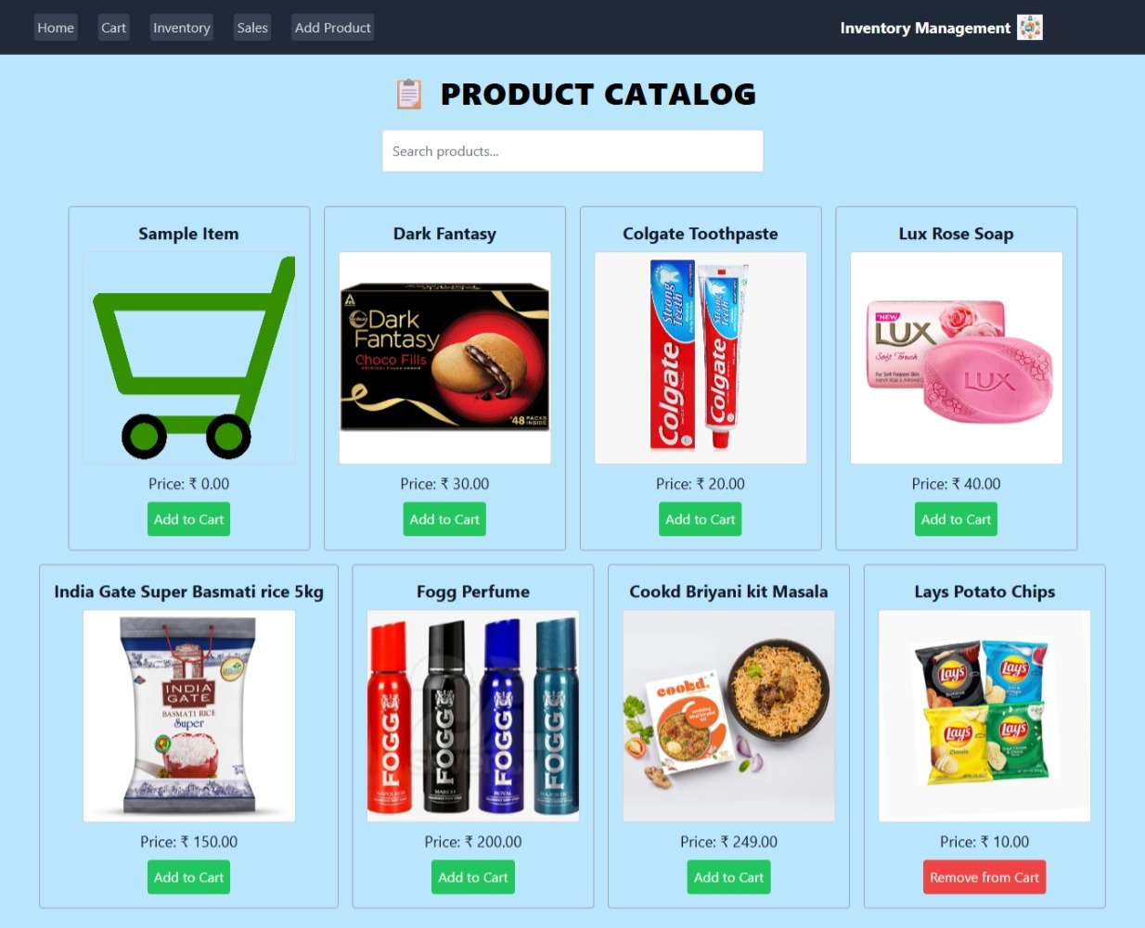

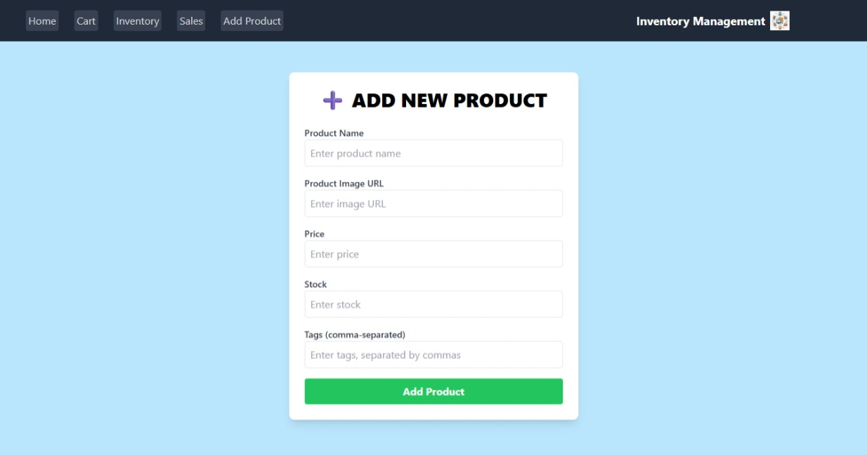

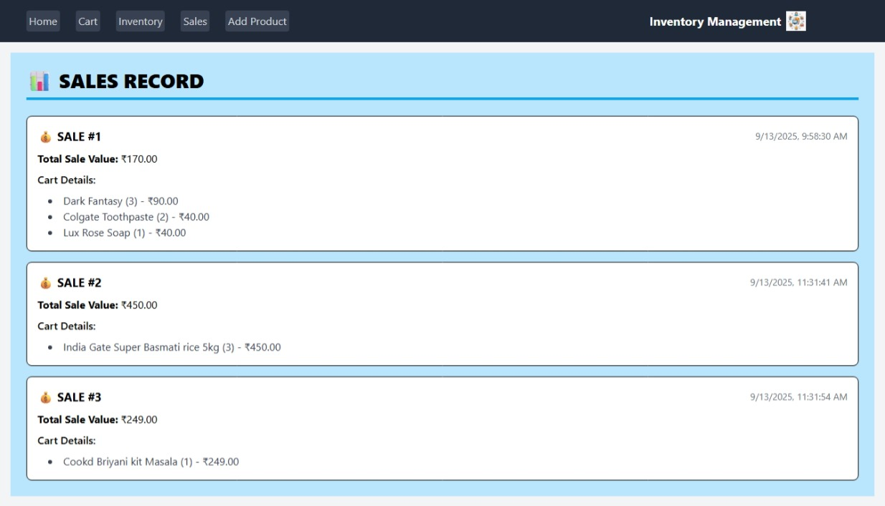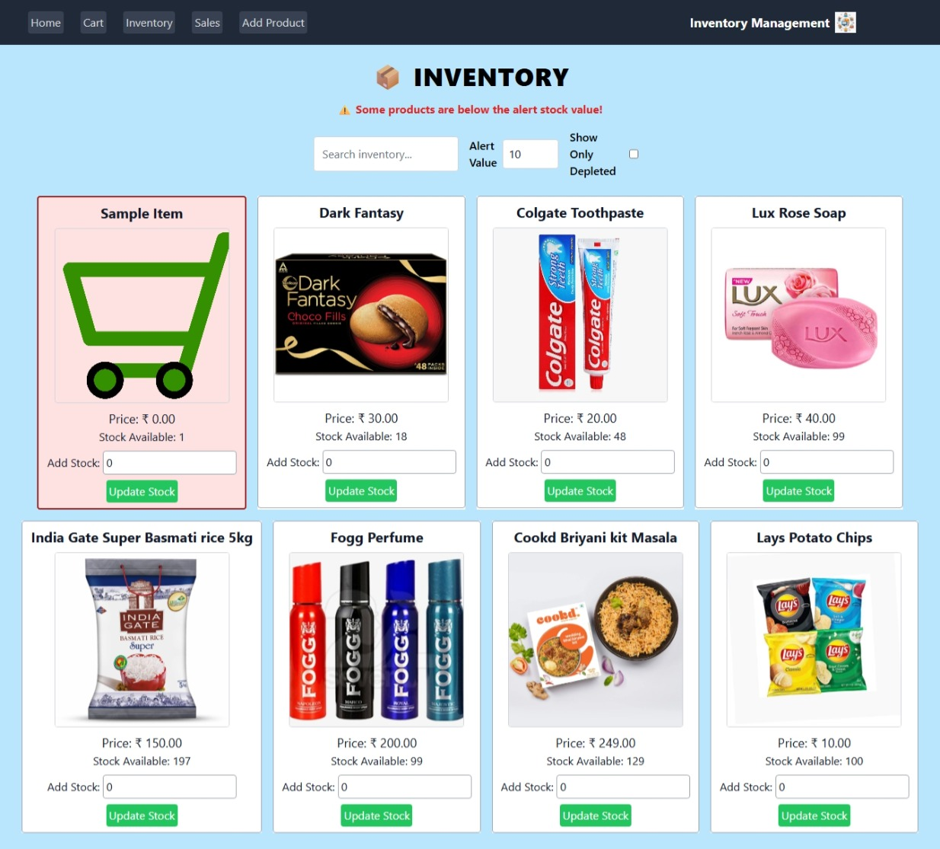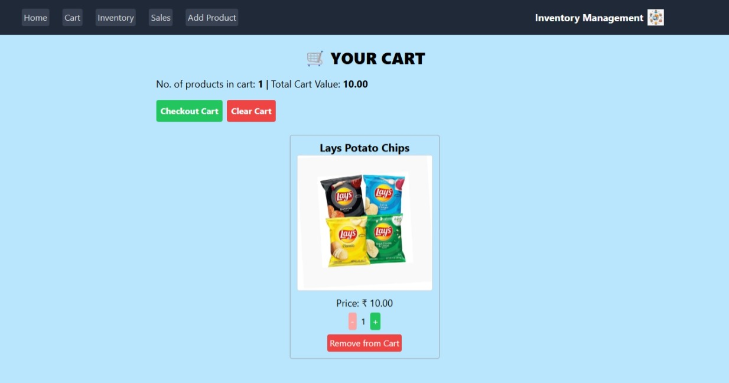

**DEMO LINK:** [**https://drive.google.com/drive/folders/1A3GO9_-DmiKrYBurz2QMGT7_FiXO0DSn?usp=sharing**](https://drive.google.com/drive/folders/1A3GO9_-DmiKrYBurz2QMGT7_FiXO0DSn?usp=sharing)

**Local: http://localhost:3001**

**On Your Network: http://192.168.1.156:3001**

# 